Ideation Phase

Define the Problem Statements

|  |  |
| --- | --- |
| Date | 14 October 2022 |
| Team ID | PNT2022TMID05259 |
| Project Name | Smart waste management system for metropolitan cities |
| Maximum Marks | 4 Marks |

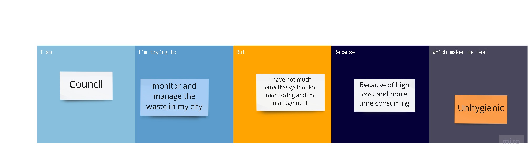

|  |  |  |  |  |  |
| --- | --- | --- | --- | --- | --- |
| Problem  Statement  (PS) | I am  (Customer) | I am trying to | But | Because | Which makes me  feel |
| PS-1 | Council | Monitor the  waste in my  city | I have not much  effective system for  monitoring | Because of high cost | unhygienic |
| PS-2 | Council | Manage the waste in my city | I have not much effective system for managing | Because of more time consuming | unsafe |